**Year 10 Physics End of Topic Test**

**Chapter 8 and 9.1**

**Formula you may need /41**

[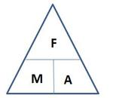](http://www.google.com.au/url?sa=i&rct=j&q=force+mass+acceleration+triangle&source=images&cd=&cad=rja&docid=O6V53PkQA165NM&tbnid=vhNrW-efYEJTlM:&ved=0CAUQjRw&url=http://jdevlin.pottsgrove.wikispaces.net/Physics+Tasks+2012&ei=z6IRUqS2NYyXkgXUoIDwCg&psig=AFQjCNGaoVG_TT9V-bDQMdMZk8qwyYJa6Q&ust=1376973888721903)[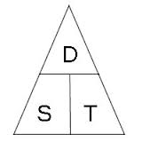](http://www.google.com.au/url?sa=i&rct=j&q=speed%20distance%20time%20triangle&source=images&cd=&cad=rja&docid=l-Td1q_Q0MI0IM&tbnid=cC1NHwB6_ZXB3M:&ved=0CAUQjRw&url=http://www.skoool.co.za/studynotes/maths/id270.htm&ei=haIRUr72K8GHkQX8qoHACw&psig=AFQjCNFf-ofXYSPuXljl_uBwHvbcdC6D5A&ust=1376973815450016)

[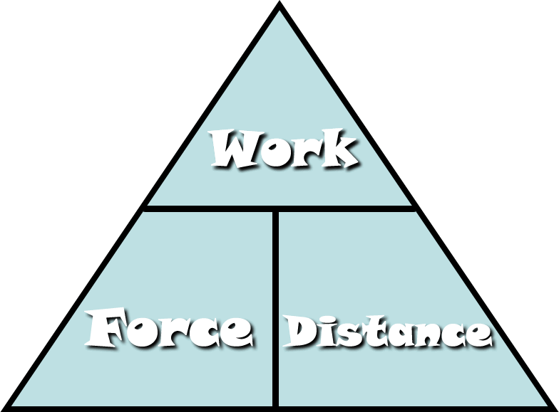](http://www.google.com.au/url?sa=i&rct=j&q=work+force+distance+triangle&source=images&cd=&cad=rja&docid=Fi7mPF8FJi6IOM&tbnid=aV4S5kcpYVNcwM:&ved=0CAUQjRw&url=http://fhm.fhsd.k12.mo.us/jhughes/Hughes/Units/Work&MachinesContent.htm&ei=0aMRUtjOGYyXkgXUoIDwCg&psig=AFQjCNG-nrT1bFGRuWdPLe1VAUwfrjBuYQ&ust=1376974154992588)

[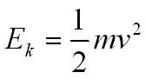](http://www.google.com.au/url?sa=i&rct=j&q=kinetic+energy+formula&source=images&cd=&cad=rja&docid=BZzVErZRq5TMSM&tbnid=KgZmomeJCTMjHM:&ved=0CAUQjRw&url=http://physicsnet.co.uk/a-level-physics-as-a2/mechanics/conservation-of-energy/&ei=UaQRUtzjCsi9kQXBxoGIDQ&psig=AFQjCNH3mfN8ppal1Ay4KsML7bw7tdoQKA&ust=1376974264173183)[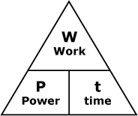](http://www.google.com.au/url?sa=i&rct=j&q=power+woek+time+triangle&source=images&cd=&cad=rja&docid=smEqr3_xk2x1UM&tbnid=FClwhBw-QCE5sM:&ved=0CAUQjRw&url=http://courses.learn60.ca/mod/book/tool/print/index.php?id=18292&ei=DKQRUvmSBoH-kgXw5oDYCg&psig=AFQjCNGFckk2PLfTo6F-_nHw8K9GjonyFA&ust=1376974213287723)

Ek = ½ ms2

[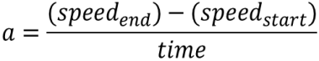](http://www.google.com.au/url?sa=i&rct=j&q=formula+acceleration&source=images&cd=&docid=n1BQvXMu3V1gnM&tbnid=tyy5e7co4fxZgM:&ved=0CAUQjRw&url=http://www.etorgerson.net/WebPages/ScienceUnits/A04_Acceleration.html&ei=ivH1UbrJMIiPkwW0pYD4Bg&psig=AFQjCNGKaO8mY3zS4cauOZdzzpsrQErjaw&ust=1375159034805046)

[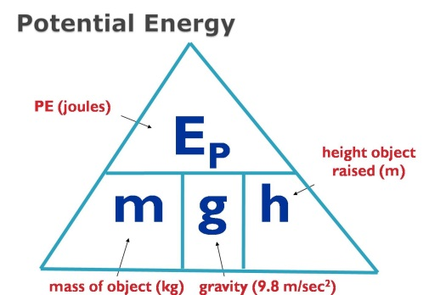](http://www.google.com.au/url?sa=i&rct=j&q=potential+energy+formula&source=images&cd=&cad=rja&docid=2H-GFaF9wBc-AM&tbnid=AD-1C8B0bBkYWM:&ved=0CAUQjRw&url=https://www.allthink.com/v/potentialenergy&ei=hqQRUs2qJsiNkAWSp4DICQ&psig=AFQjCNFHln3I7-BEBHAERUecIisFWqbMGw&ust=1376974319301500)

**Multiple Choice Answer Sheet**

1. A B C D 16. A B C D

2. A B C D 17. A B C D

3. A B C D 18. A B C D

4. A B C D 19. A B C D

5. A B C D 20. A B C D

6. A B C D 21. A B C D

7. A B C D 22. A B C D

8. A B C D

9. A B C D

10. A B C D

11. A B C D

12. A B C D

13. A B C D

14. A B C D

15. A B C D

[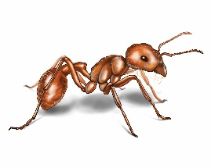](http://www.google.com.au/url?sa=i&rct=j&q=ant&source=images&cd=&cad=rja&docid=xnY1A86yla2paM&tbnid=RzulS6ugMKx4fM:&ved=0CAUQjRw&url=http://www.orkin.com/ants/harvester-ant/&ei=dZs7UrXWFNDDkAWDrIHoDA&psig=AFQjCNH_SG2m2KFbnhWkRaDTwREnye2S-g&ust=1379724529024052)**1** What distance would an ant, crawling at a speed of 2 centimetres per second, cover in an hour?

A 120 cm

B 7200cm

C 1200m

D 7200m

[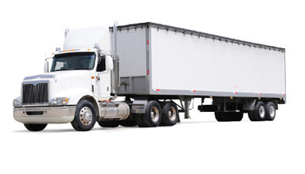](http://www.google.com.au/url?sa=i&rct=j&q=truck&source=images&cd=&cad=rja&docid=GlxTeazisYpVTM&tbnid=cIb0qlzGCFXRvM:&ved=0CAUQjRw&url=http://www.manheim.com.au/trucks-machinery&ei=5Zs7UpzUJsfXkAX_vYC4CA&psig=AFQjCNEoBMmdlbny4o7ldQaAxL4nTTAhMw&ust=1379724629270576)

**2** A truck travels at a speed of 16 m/s. This is equivalent to a speed of:

A 0.96 km/h

B 4.44 km/h

C 5.76 km/h

D 57.6 km/h

[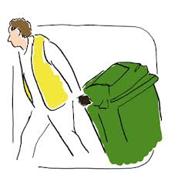](http://www.google.com.au/url?sa=i&rct=j&q=put+out+wheely+bin&source=images&cd=&cad=rja&docid=29pzR1WcQ3u_eM&tbnid=3Co3y0nBE_mw2M:&ved=0CAUQjRw&url=http://www.oxfordshire.gov.uk/cms/content/rubbish-and-recycling-oxfordshire&ei=g9A7UsKpCIKIkwWw6YH4Dg&psig=AFQjCNGHJ3ZxsU6cRHbs3zRqdJid1aroRw&ust=1379738041806358)**3** Chris applies a 90 N to a 65 kg bin. The bin will accelerate at:

A 0.138 m/s2

B 1.38 m/s2

C 5850 m/s2

D 58.5 m/s2

**4** Power is the rate at which energy is supplied. What power is needed to supply 6000 J to lift a 15kg child 10 m up a vertical cliff face in 5 seconds?

A 1200 J/s

B 120 J/s

C 300 000 J/s

D 30 000 J/s

**5** Look at the three pieces of ticker tape below, labelled A, B and C.

Choose the answer that explains each piece correctly.

[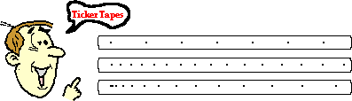](http://www.google.com.au/url?sa=i&rct=j&q=ticker+tape+speed&source=images&cd=&cad=rja&docid=wMhrNsjROP9a0M&tbnid=vzACHjSPZdrteM:&ved=0CAUQjRw&url=http://www.nileswestils.com/ILS/Acceleration.html&ei=-tA7UrGqKIfdkgXOt4HIBA&psig=AFQjCNH19iGDLCD5X9W_FaHQYkKvniD58g&ust=1379738197384806)

**A**

**B**

**C**

|  |  |  |  |
| --- | --- | --- | --- |
|  | Piece A | Piece B | Piece C |
| A | Decelerating | Maintaining a constant speed | Accelerating |
| B | Maintaining a constant speed | Accelerating | Decelerating |
| C | Accelerating slowly | Maintaining a constant speed | Decelerating |
| D | Maintaining a constant Speed | Accelerating Slowly | Accelerating faster |

Cables

**[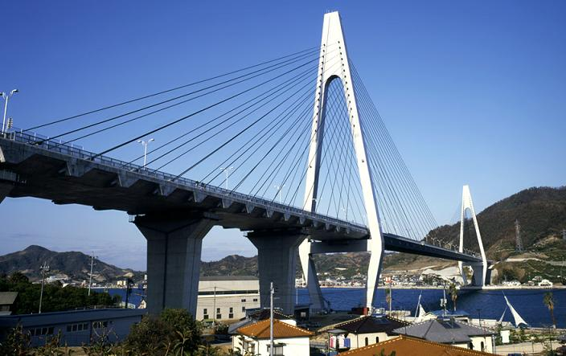](http://www.google.com.au/url?sa=i&rct=j&q=cable%20structure&source=images&cd=&docid=Ia5-jEs6rb-4pM&tbnid=kb2XZHnsRVs7bM:&ved=0CAUQjRw&url=http://www.tradekorea.com/sell-leads/0322/Suspension_Systems.html&ei=q5w7Uq_SIcvbkgWVtICYBw&psig=AFQjCNGzYY-pXnBpvpX-fhpSwjrduWiA5A&ust=1379724824159105)6** Two forces stretch a cable within a structure. Which of the following best describes the cable?

A The cable is in compression.

B The cable is in tension.

C The cable is being stretched by gravity.

D The cable is unbalanced.

**7** When a door or window sticks it indicates that the structure:

A has partly failed

B has forces acting on it

C has all of its forces balanced

D has no forces acting on it

**8** An aircraft is flying in a straight line at constant altitude and at a constant speed. What can be said about the forces on the aircraft?

A The forces are unbalanced.

B The forces are balanced.

C The forces are compression forces.

D The aircraft is accelerating.

**9** When standing, your legs are in:

A compression

B tension

C failure

D friction

**10** Sandstone is a building material that is strong under:

A compression only

B tension only

C both compression and tension

D all forces

**11** A cable is stretched by a tensile force of 20 MN (20 000 000 N). The cross-sectional area of the cable is 0.5 m2. The stress in the cable is:

A 0.025 m2/MN

B 40 N/m2

C 40 MN/m2

D 40 000 000 MN/m2

**12** A cable was placed under tension until just before it broke. Which of the following diagrams best shows the cable just before it broke?

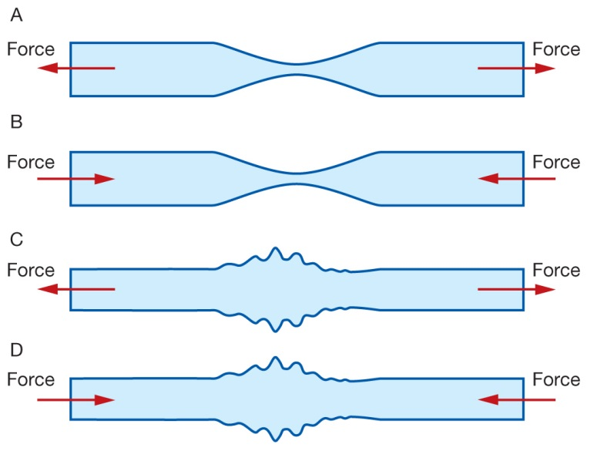

**13** The Sydney Harbour Bridge (diagram below) is an example of a:

A bowstring arch bridge

B cable-stayed bridge

C suspension bridge

D beam bridge

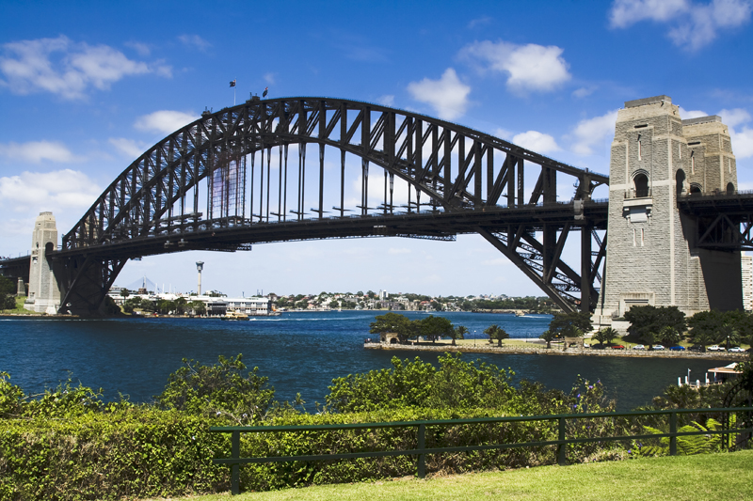

**[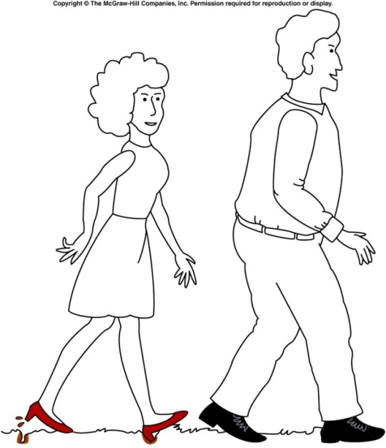](http://www.google.com.au/url?sa=i&rct=j&q=pressure+high+heel&source=images&cd=&cad=rja&docid=nxP8BgFtQrkhwM&tbnid=dVIUZoWEAPzlTM:&ved=0CAUQjRw&url=http://onlinephys.com/pressure.html&ei=hfU3Uoq9C8WfkwW2toHQAg&psig=AFQjCNGIEB4RESz64D3f84yVrSv_95GNLw&ust=1379485420790197)14** Which of the following is **true** about the diagram of the man and woman walking?

A The woman is making marks in the ground because she is placing more force on the grass

B The man is not making any marks on the ground because he is placing less force on the grass

C The woman is making marks on the ground because her shoes have less area touching the ground

D The man’s shoes are not making any marks on the ground because his have less area touching the ground

**15** Which of the following has kinetic energy?

A A bike parked on a hill.

B A child running.

C A stretched balloon.

D A bumblebee hovering in the same spot.

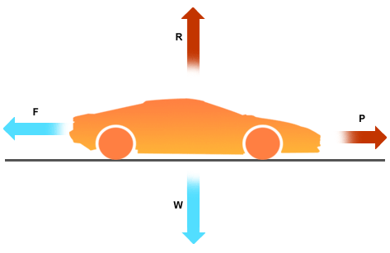

**16** Which of the following is **correct** about the movement of the car?

A The car is still

B The car is at a constant speed

C The car is accelerating

D The car is decelerating

[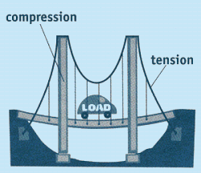](http://www.google.com.au/url?sa=i&rct=j&q=tension+and+compression+structure&source=images&cd=&cad=rja&docid=G3lxRbpcGNLJsM&tbnid=oJ5zGxfMkpJX2M:&ved=0CAUQjRw&url=http://www.carondelet.pvt.k12.ca.us/Family/Math/03210/page4.htm&ei=V9c7UomxLYzFkwXF-IDIAw&psig=AFQjCNEYORpIxQY7OLCRETbBpZif83rsvA&ust=1379739804442263)

17 Which of the following is **true** about this diagram of a bridge?

**A**

A A shows an area under compression and B shows an area under tension

**B**

B A shows an area under tension and B shows an area under compression

C Both A and B are under tension

D Both A and B are under compression.

**18** Leslie runs a race that starts and finishes at the same point. If the race was 1000 metres, what was Leslie’s displacement at the end of the race?

A 1000 metres

B 500 metres

C 10 metres

D 0 metres

**19** Leslie ran a second race but is unable to finish after spraining an ankle and 120 m east of the finish line. Given that the distance to be run in the race was 1000 m, and that the finish line was where the race started, the displacement of the racehorse is now:

A 120 m east

B 120 m west

C 880 m east

D 880 m west

**20** Which of the following is **incorrect** about the speed time graph below?

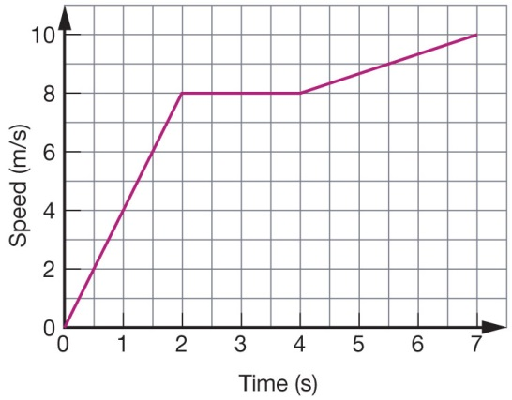

A The speed after 3 seconds is 8m/s

B The distance travelled after 2 seconds is 12m

C The distance travelled after 3 seconds is 8m

D The speed after 7 seconds is 10m/s

**21** Which of the following explains Newtons First Law?

A The motion of an object will not change if all the forces acting on it are balanced

B For every force there is an equal and opposite force

C An object will accelerate in the direction of an unbalanced force

D F = M x A

**22** Which of the following is **not** an example of potential energy?

A A bike parked on a hill.

B A skateboard moving down a hill

C A stretched balloon.

D A sandwich

**Short Answer**

**1** Classify the following as situations in which forces are balanced or unbalanced: 4

a A motorbike is accelerating away from traffic lights.

b A car is travelling at 100 km/h straight down a freeway.

c A surfer falls off their surfboard.

d A bird flies into a window and bounces off.

**2** Construct diagrams showing forces: 2

a in compression

b in tension.

**3** Explain why a stretched cable is most likely to break at a scratch. You may use a diagram to help you. 2

**4** Describe a simple way of determining whether part of a structure is in compression or tension. 1

**5**` Classify each of the components (labelled a, b and c) in the structure below as being in compression or tension. 3

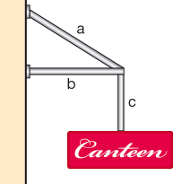a

b

c

**6** When a structure fails, it doesn’t always fall down. List two ways you can tell that some minor failure has occurred in a structure.

[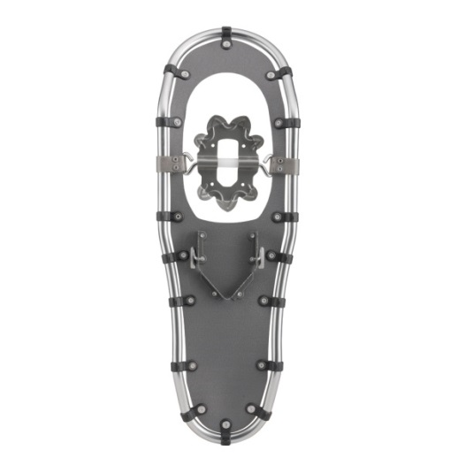](http://www.google.com.au/url?sa=i&rct=j&q=snow+shoes+pressure&source=images&cd=&cad=rja&docid=cm8BbMfRO8yOHM&tbnid=Ku39sujIMBYOgM:&ved=0CAUQjRw&url=http://www.louisgarneau.com/ca-en/product/0/1493980/_/BLIZZARD_930_SNOWSHOES&ei=fPM3UuywOofJkgXw44DIDg&psig=AFQjCNHkODeRA6Jg58j7gcAG6ZoSEgQXpA&ust=1379484887573019)**7** This is a picture of a snow shoe, which is a shoe designed to be strapped to your boots to help you walk in snow. Explain how the snow shoe makes it easier to walk in snow. 2

**8** Fill in the following table 3

|  |  |
| --- | --- |
|  | **Units** |
| Force |  |
| Energy |  |
| Work |  |
| Speed |  |
| Acceleration |  |
| Kinetic Energy |  |